

|  |
| --- |
|  |
| Ministry of Tourism and Antiques |
| |  |  |  | | --- | --- | --- | | Saba Hatamleh | 9/28/20 | Web Development |   2 |

Supervised by:

Dr. Jalal Kiswani

Dr. William Smairat

Ms. Jacquelyn Brown

Ms. Hana AL Rasheed

Contents

I. Introduction 2

II. Project Details 2

Technology 2

Requirements 2

Design 2

Development 3

Testing 3

Deployment 3

III. Screenshots 3

IV. Source Code Excerpts 3

V. Conclusion 4

# Introduction

It is a long established fact that a reader will be distracted by the readable content of a page when looking at its layout. The point of using Lorem Ipsum is that it has a more-or-less normal distribution of letters, as opposed to using 'Content here, content here', making it look like readable English. Many desktop publishing packages and web page editors now use Lorem Ipsum as their default model text, and a search for 'lorem ipsum' will uncover many web sites still in their infancy. Various versions have evolved over the years, sometimes by accident, sometimes on purpose (injected humour and the like).

It is a long established fact that a reader will be distracted by the readable content of a page when looking at its layout. The point of using Lorem Ipsum is that it has a more-or-less normal distribution of letters, as opposed to using 'Content here, content here', making it look like readable English. Many desktop publishing packages and web page editors now use Lorem Ipsum as their default model text, and a search for 'lorem ipsum' will uncover many web sites still in their infancy. Various versions have evolved over the years, sometimes by accident, sometimes on purpose (injected humour and the like).

# Project Details

## Technology

It is a long established fact that a reader will be distracted by the readable content of a page when looking at its layout. The point of using Lorem Ipsum is that it has a more-or-less normal distribution of letters, as opposed to using 'Content here, content here', making it look like readable English. Many desktop publishing packages and web page editors now use Lorem Ipsum as their default model text, and a search for 'lorem ipsum' will uncover many web sites still in their infancy. Various versions have evolved over the years, sometimes by accident, sometimes on purpose (injected humour and the like).

## Requirements

It is a long established fact that a reader will be distracted by the readable content of a page when looking at its layout. The point of using Lorem Ipsum is that it has a more-or-less normal distribution of letters, as opposed to using 'Content here, content here', making it look like readable English. Many desktop publishing packages and web page editors now use Lorem Ipsum as their default model text, and a search for 'lorem ipsum' will uncover many web sites still in their infancy. Various versions have evolved over the years, sometimes by accident, sometimes on purpose (injected humour and the like).

## Design

It is a long established fact that a reader will be distracted by the readable content of a page when looking at its layout. The point of using Lorem Ipsum is that it has a more-or-less normal distribution of letters, as opposed to using 'Content here, content here', making it look like readable English. Many desktop publishing packages and web page editors now use Lorem Ipsum as their default model text, and a search for 'lorem ipsum' will uncover many web sites still in their infancy. Various versions have evolved over the years, sometimes by accident, sometimes on purpose (injected humour and the like).

## Development

It is a long established fact that a reader will be distracted by the readable content of a page when looking at its layout. The point of using Lorem Ipsum is that it has a more-or-less normal distribution of letters, as opposed to using 'Content here, content here', making it look like readable English. Many desktop publishing packages and web page editors now use Lorem Ipsum as their default model text, and a search for 'lorem ipsum' will uncover many web sites still in their infancy. Various versions have evolved over the years, sometimes by accident, sometimes on purpose (injected humour and the like).

## Testing

It is a long established fact that a reader will be distracted by the readable content of a page when looking at its layout. The point of using Lorem Ipsum is that it has a more-or-less normal distribution of letters, as opposed to using 'Content here, content here', making it look like readable English. Many desktop publishing packages and web page editors now use Lorem Ipsum as their default model text, and a search for 'lorem ipsum' will uncover many web sites still in their infancy. Various versions have evolved over the years, sometimes by accident, sometimes on purpose (injected humour and the like).

## Deployment

It is a long established fact that a reader will be distracted by the readable content of a page when looking at its layout. The point of using Lorem Ipsum is that it has a more-or-less normal distribution of letters, as opposed to using 'Content here, content here', making it look like readable English. Many desktop publishing packages and web page editors now use Lorem Ipsum as their default model text, and a search for 'lorem ipsum' will uncover many web sites still in their infancy. Various versions have evolved over the years, sometimes by accident, sometimes on purpose (injected humour and the like).

# Screenshots

It is a long established fact that a reader will be distracted by the readable content of a page when looking at its layout. The point of using Lorem Ipsum is that it has a more-or-less normal distribution of letters, as opposed to using 'Content here, content here', making it look like readable English. Many desktop publishing packages and web page editors now use Lorem Ipsum as their default model text, and a search for 'lorem ipsum' will uncover many web sites still in their infancy. Various versions have evolved over the years, sometimes by accident, sometimes on purpose (injected humour and the like).

# Source Code Excerpts

It is a long established fact that a reader will be distracted by the readable content of a page when looking at its layout. The point of using Lorem Ipsum is that it has a more-or-less normal distribution of letters, as opposed to using 'Content here, content here', making it look like readable English. Many desktop publishing packages and web page editors now use Lorem Ipsum as their default model text, and a search for 'lorem ipsum' will uncover many web sites still in their infancy. Various versions have evolved over the years, sometimes by accident, sometimes on purpose (injected humour and the like).

# Conclusion

It is a long established fact that a reader will be distracted by the readable content of a page when looking at its layout. The point of using Lorem Ipsum is that it has a more-or-less normal distribution of letters, as opposed to using 'Content here, content here', making it look like readable English. Many desktop publishing packages and web page editors now use Lorem Ipsum as their default model text, and a search for 'lorem ipsum' will uncover many web sites still in their infancy. Various versions have evolved over the years, sometimes by accident, sometimes on purpose (injected humour and the like).

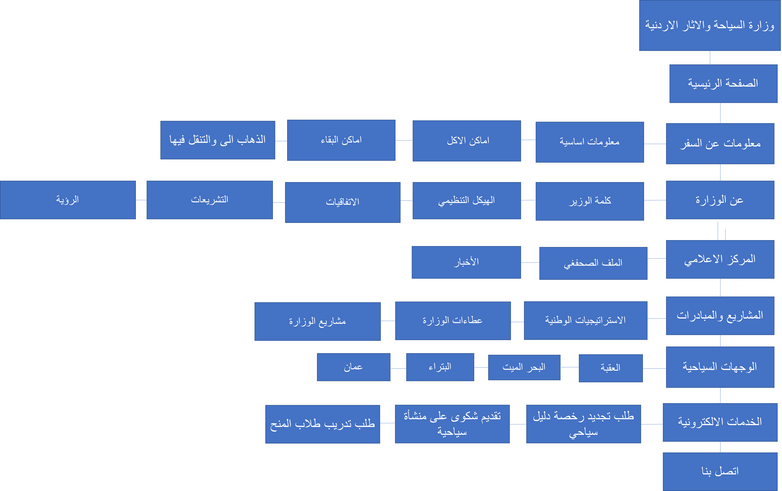

وزارة السياحة والاثار الاردنية

الصفحة الرئيسية

معلومات عن السفر

عن الوزارة

المركز الاعلامي

المشاريع والمبادرات

الوجهات السياحية

الخدمات الالكترونية

معلومات اساسية

اماكن الاكل

اماكن البقاء

كلمة الوزير

الهيكل التنظيمي

الاتفاقيات

التشريعات

الملف الصحفغي

الأخبار

الاستراتيجيات الوطنية

عطاءات الوزارة

مشاريع الوزارة

العقبة

البحر الميت

البتراء

عمان

اتصل بنا

الذهاب الى والتنقل فيها

طلب تجديد رخصة دليل سياحي

تقديم شكوى على منشأة سياحية

طلب تدريب طلاب المنح